TOVS - Frequently Asked Questions

I would like an application form for the Trading Online Voucher.
All applicants of the Trading Online Voucher must first attend a mandatory Trading Online Voucher informational webinar. Please see our Trading Online Voucher Scheme webpage for the next webinar date.

Is my business eligible for a Trading Online Voucher?
To qualify for a Trading Online Voucher, businesses must be trading for a minimum of 6 months and employ no more than 10 members of staff.
There are categories of business excluded from the Trading Online Voucher Scheme as defined by their NACE code. You can find a list of ineligible NACE codes HERE.
The NACE code for a business can be checked via CRO registration.
The onus is on the business to make sure they are eligible before submitting an application form.
Full terms and conditions of the Trading Online Voucher can be found on our Trading Online Voucher Scheme webpage.

I have registered for a Trading Online Voucher webinar but have not received the Zoom link.
The links to training events are sent a day or two before the event takes place. Please make sure to check your spam / junk folder to ensure the email has not been misrouted.
Please make sure you sign the digital attendance sheet at the beginning of the webinar.

I recently attended the Trading Online Voucher Webinar but have not received an application form?
Our application form is available by clicking Apply Now on our Trading Online Voucher Scheme webpage HERE

Have you received my application form?
We have received your application as soon as you get the confirmation message on screen. A confirmation email of submission will also be sent to you from noreply@submit.com

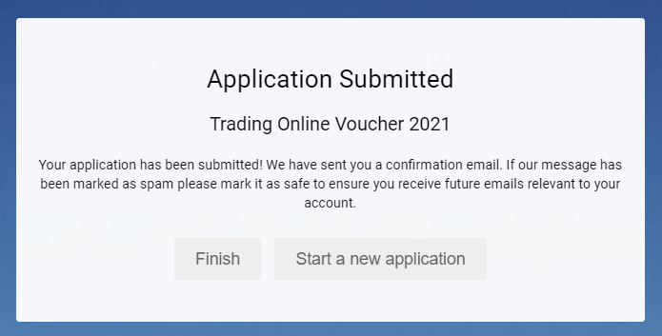

I cannot upload my quotes to Submit; I get an error message.
To resolve this issue please complete your application on a desktop computer, preferably using the Chrome web browser. Clear your internet cookies and reload the web browser.
Files should not exceed 10MB in size.

I have completed my project; how do I claim the voucher?
To claim your voucher, you will need to return the items listed on your Letter of Offer.
Please return via email;
1) your signed Drawdown form
2) your Company Registration Office (CRO) number
3) up to date Tax Clearance Certificate
4) all original invoice(s) from your Supplier(s) showing their Tax Number, CRO Number or VAT number
5) a confirmation of completion form(s)
6) receipts and bank statements showing proof of payment from your business to your Supplier(s)
7) your completed Supplier Setup form and bank header (if not submitted already)

What is a ‘Confirmation of Completion’ form?
This is a declaration from both you & your supplier, noting that the work they were employed to carried out has been completed and paid for in full.
It should be returned with your drawdown application form.

I have submitted my claim; when will I be paid?
Once we have received your claim it goes through an internal review process and if all is in order it will be sent to the Finance Dept of the County Council for payment.
The payment take up to approx. 4 weeks to reach your account from the date it is sent for payment.

I would like to apply for a second Trading Online Voucher; how do I do this?
To apply for a second Trading Online Voucher, you must first receive the payment of your first voucher into your nominated bank account.
If you have completed a Trading Online Voucher webinar within the last 9-month period then you can apply again through the online portal.
If it has been over 9 months since you attend a webinar, you must attend another information seminar.
Since 8th Feb 2021 some business categories who were previously eligible for a Trading Online Voucher are no longer eligible as defined by their NACE code. You can find a list of ineligible NACE codes on our Trading Online Voucher Scheme webpage.
The onus is on the business to make sure they are eligible before submitting an online application form.
Full terms and conditions of the Trading Online Voucher can be found on our Trading Online Voucher Scheme webpage.

