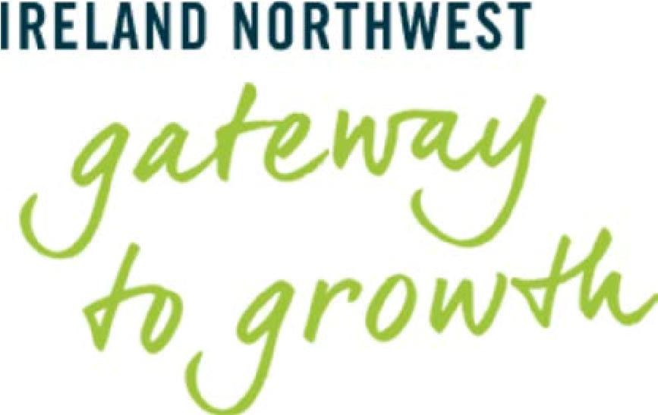

Ireland North West Trade &
Investment Missions 2018

Philadelphia (18-20 June 2018)
& Boston (13-16 November 2018)

Closing Date for Expressions of Interest (EoI):
Friday 16th March 2018

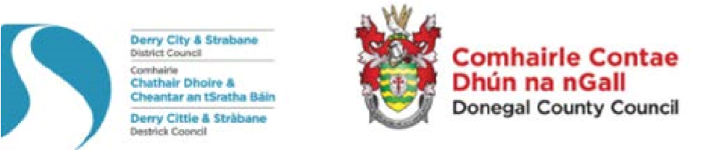
In conjunction with and supported by The Executive Office and the Irish Government

Thank you for your interest in this trade mission.
Background to Missions
The Ireland Northwest Trade & Investment Missions are being led by the Mayors and Chief Executives of Donegal County Council and Derry City and Strabane District Council.
Both Councils have been building relationships in the NE USA market as part of a wider investment strategy to promote Ireland Northwest’s compelling and attractive investment proposition. Over this time the local authorities have continued to build relationships in-market with key education, political and economic stakeholders. Visits such as these facilitate connections to high level government contacts and US business leaders. This will be the Councils third trade mission to Boston and Philadelphia has been introduced to the programme.
The dual aims are to assist indigenous companies to do business in export markets and to raise the profile of the NW of Ireland in the NE coast of USA market as an investment destination. The objectives are to facilitate market entry for SMEs that are export-ready and have an ability to enter the US market; establish new partnerships and strengthen economic, political and cultural relationships between Ireland NW and the US.
The Councils will be working with business support organisations and Chambers of Commerce in the respective cities to organise business matching, B2B meetings, B2C and networking opportunities for participating companies.

Market Overview
Why Boston?
Boston is located in the Northeastern region of the USA and is the USA’s most economically developed, densely populated, and culturally diverse region. The Northeastern region comprises 9 states (Maine, New Hampshire, Vermont, Massachusetts, Rhode Island, Connecticut, New York, New Jersey, and Pennsylvania). These states account for approximate 23% of USA GDP.
The United States Bureau of Economic Analysis estimates that the Massachusetts gross state product in 2015 was US$485 billion, Thirteen Fortune 500 companies are located in Massachusetts. The state is consistently recognised as one of the best states to do business in the USA and the most innovative state in the USA. With a population of 6,811,779 Massachusetts provides access to a large number of potential customers. There are 50 cities and 301 towns in Massachusetts.
Boston is the state capital and largest city in Massachusetts. A global city, Boston is placed among the top 30 most economically powerful cities in the world. Encompassing $363 billion, the Greater Boston metropolitan area has the sixth-largest economy in the country and 12th-largest in the world.
Key economic sectors include higher education, biotechnology, information technology, finance, health care, tourism, and defence. The state has recently witnessed significant growth in the professional and business services sector.

Why Pennsylvania?
Pennsylvania is an economic powerhouse of the world. It’s economy is the 19th largest in the world, with a GDP that’s comparable to Turkey, and larger than Saudi Arabia or Switzerland. Located only a day away from nearly 40 percent of the U.S. population; 60 percent of the Canadian population and 4 of the 10 largest U.S. markets, great companies are built and do business in Pennsylvania — including international ones.

Pennsylvania is home to more than 6,450+ foreign-owned companies employing 334,000 people, with easy access to 12.8 million potential customers/clients and a 6.4 million-strong workforce. Pennsylvania has one of the largest international networks of all states in the U.S. Irish companies have flourished in the state with 232 locations in Pennsylvania providing 13,945 jobs. Leading Irish companies that have established in the state include Sharp Corporation, Eaton Corporation and Ashfield Healthcare. British companies have also flourished in the state with 989 locations in Pennsylvania providing 49,296 jobs. Leading British companies that have established in the state include Glaxosmithkline LLC, Astrazeneca Pharmaceuticals LP and AON Hewitt LLC.

Key areas of opportunity in the State are agri-food, manufacturing & engineering, life sciences. ICT and energy as well as the shared cultural and heritage ties

Philadelphia (America’s 5th largest city) and Pittsburgh are Pennsylvania’s two largest cities.

Why Philadelphia?
A diverse city with a growing international reputation of vibrancy and excellence, 12% of Philadelphia’s population are foreign-born or immigrants, located midway between New York and Washington DC Philadelphia is a strategic location on the East Coast, and is at the centre of a dynamic and thriving region of over 6.4 million people. The City’s economy is anchored by a diverse set of industries, such as life sciences and healthcare, professional services, advanced manufacturing and logistics, hospitality and a growing start up community.

The Philadelphia region has one of the strongest life sciences sector in the country with core concentrations in gene therapy, biotech, medical devices, pharmaceuticals, diagnostics and health IT. Philadelphia has the largest share of Education and Health Services employment of any major city in the United States and 80% of U.S. pharmaceutical companies located within a 2 hour drive.

With the 5th fastest growing creative sector in the country and one of the most vibrant art, theatre, music and museum scenes in the country; private creative firms thrive in Philadelphia.

Philadelphia’s rich manufacturing heritage has developed into a diverse and sophisticated advanced manufacturing sector today. Philadelphia’s central location and enviable transportation infrastructure support industries as varied as aerospace, electronics, chemicals, metal manufacturing, and apparel.

With tens of thousands of tech workers, Philadelphia’s tech scene is a tight-knit community that finds collaboration and innovation from within. Entrepreneurs can access a burgeoning network of incubator, multitenant, and co-working spaces across the city with support from more than 70 organisations.

Who should consider joining the mission?
If your company has serious intentions to enter the US market, this opportunity could be for you.
Companies should be looking to initiate, develop and expand export relationships in the US market. This mission present unique opportunities and benefits to participants including access to key economic and government decision-makers, in-market intelligence, unparalleled networking opportunities, business-to-business meetings with potential partners and an opportunity to seek valuable market insight and expose your business to new market opportunities.
The mission is focusing on export ready businesses in the following sectors; Creative Digital Technologies, Life and Health Sciences and Advanced Manufacturing, Materials and Engineering (AMME).

The Benefits of Joining this Mission:
- Saves you time and money
- In-market professional expertise
- Meet other Ireland NW companies, share intelligence and valuable networks with other trade mission participants
- Pre-mission assistance programme including pre-visit briefings, guidance on market entry strategies and tax and Pre-mission preparation workshops
- One-to-one B2B appointments and business networking events screened to match specific objectives of the business
- Positive opportunities to further develop relationships with high-level decision makers across business, political and civic contacts
- Extensive local media coverage to heighten your presence in the market
- Post-mission follow-up support

Financial Support
Selected companies will be eligible for financial assistance to partly cover travel and accommodation costs. Eligible companies can claim up to 50% towards flight costs (economy fares only) and up to £100 (€117) per night hotel accommodation for max 3 nights.

Travel and Accommodation Costs
You can make your own travel arrangements but it is highly recommended that you stay in the mission hotel in order to make the most of networking opportunities.

Eligibility
To participate in this trade mission your business must be established within the Ireland North West region, which comprises County Donegal and Derry City & Strabane District Council Area. Participation is limited and companies will be selected based on their export readiness, and the suitability of their service/product offering for the relevant markets.

Services not included in the visit:
Insurance has not been included. Mission members are strongly advised to take out adequate travel and sickness insurance.

Express Your Interest
NW business are invited to express Expression of Interest in joining these delegations by completing the short form below. Your expression of interest does not guarantee participation.
A Council representative will contact you to facilitate further assessment and advise on conducting specific market research for your company and products/service, in an effort to assess the potential opportunities that are matched for your business.
Contacts:
For companies operating in County Donegal:  Donegal Local Enterprise Office  Michael Tunney, Head of Enterprise  Joanne Kilmartin, Diaspora Executive  E: michael.tunney@leo.donegalcoco.ie  joanne.kilmartin@leo.donegalcoco.ie  T: 00353 749 160 735 | For companies operating in Derry City and Strabane District:  Derry City & Strabane District Council  Rosalind Young, Investment Manager  Adam Goodall, Investment Officer  investment@derrystrabane.com  T: +44 (0)2871 253 253 ext 6662/6661

Ireland North West Terms & Conditions
- The partner Councils will allocate mission places according to suitability to the Trade and Investment Mission
- Places are limited and not all companies may get the opportunity to participate on this occasion however may be considered for future delegations
- Until your place has been confirmed you should not pay for any travel/accommodation
- The Partner Councils are not responsible for the conduct and safety of individual mission participants whilst it will take measures to ensure a safe visit

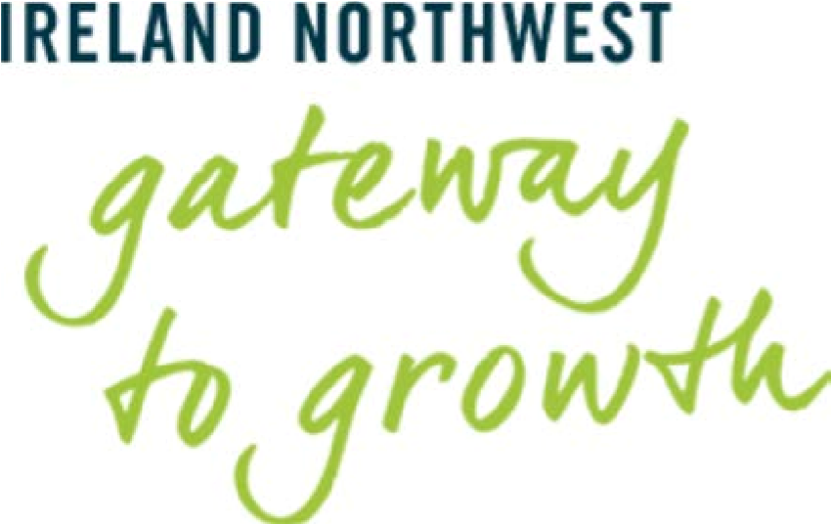

Trade Missions 2018
Expression of Interest Form
Company:

Company Registration No.
Registered Business Address

Name of Representative;
Job Title:
Tel:

Email:

Website:
No. of Employees
Business Sector  (please indicate): | Creative Digital Technology  Life & Health Sciences  AMME  Other (please specify)
Please select market of interest | Philadelphia:  Boston:
Is your company currently exporting to the US? | Yes/No
Who are your target customers (or sectors) in the proposed market?

What preliminary work have you undertaken on the potential export market?
Have you participated on any previous trade missions – when, where & with who?

Current export markets & value: | GB  NI  ROI  Other EU  US (please specify)  Non EU (please specify)
Annual Turnover  (£/€) | 2016/17  2015/16  2014/15

Declaration

Name:

Position in Company:

Signature:

Date:

