Request for Proposals for Mural at Carlow Exchange,
Potato Market, Carlow
Closing date: 12th August 2023
Introduction:
Proposals were invited from artists or arts groups working in the medium of visual art, mural art, exterior wall painting, design, collaborative or community engaged practice; to consider the development of an outdoor artistic intervention – painting the wall of the Carlow Exchange.
This wall was the canvas upon which an artist was invited to paint. The commissioned work has a dual role – to bring colour and wonder to the exchange visitors while also communicating a message of “Exchange” which is the primary focus of the space.
This project aims to:
• Encourage the renewal and revitalisation of the town by brightening up key areas
• Build strong relations through engagement with the community and business stakeholders of the town
• Further drive the current momentum towards a positive image of Carlow Town as a vibrant place to live, visit and work.

The artworks will be located on the inside brick wall at The Exchange, on Potato Market in Carlow Town Centre.
The entire length of the wall will be available for painting, and although it is a covered space, it is open to the elements and should be considered an ‘open space’ which is subject to wind and rain. The Exchange is used every Saturday by the Carlow Farmers Market from 7am until 3pm, but outside of those times the space will be available unless booked by another group.
Times for painting should be arranged with Carlow County Council’s Local Enterprise Office, and if a group is booked into the Exchange, all materials and equipment must be removed to facilitate that group, as The Exchange is hired as an empty space.
Artist commission of between €4,000 and €10,000, depending on the artist’s experience and the scale and complexity of the artwork
All practical arrangements to facilitate the installation of the artwork, including licences, plant hire, road closures, will be arranged by Carlow County Council’s Local Enterprise Office (LEO)
While it is anticipated that the work will be on display for a period of at least twelve months, Carlow County Council reserves the right to remove the artwork at any time.
What is expected of the artist:
The selected artist will be expected to work closely with the LEO to refine final concept, the scale of the work, production schedule and timelines.
Artists will be responsible for providing their own materials for the installation of the piece and will be required to provide evidence of holding Public Liability Insurance in the sum of €6.5 million, indemnifying Carlow County Council, in advance of the commencement of any work. Where an artist plans to engage others to execute the work, evidence of Employer’s Liability Insurance in the sum of €13 million will be required.
Artists will be asked to engage in social media or PR activities to support the project, although requests for anonymity will be respected. The artist will be expected to sign a contract (as outlined in the appendix of this document)

Selection Process
The commission will be selected by way of an open selection process, and the project will be curated on the basis of creating an artwork of note for the town. An individual may make multiple submissions with different suggested art works.
Submissions will be adjudicated on by Evaluation Committee using the following criteria:
- Suitability of outline proposal (30/100)
- Quality of previous work (30/100)
- Previous experience in delivering projects on time and within budget (20/100)
- Value for money (20/100)
The Evaluation Committee will make their recommendation to the Carlow County Council Public Art Working Group for approval.

Submission of Proposals
Applicants may submit multiple proposals. Collaborations are welcome.
Please send proposals to enterprise@carlowcoco.ie by 5pm 12th August 2023. Applicants are requested to provide:
• a brief resumé outlining experience to date
• an outline of the proposed artwork including an explanation of subject matter
• examples of previous work - please supply direct links to any pages/sites you wish the panel to view
• please provide your fee for the artwork of between €4,000 and €10,000 excluding VAT @ 13.5%
• two letters of reference or details of two referees.
Carlow County Council is committed to a policy of equal opportunity. The principles of inclusivity and diversity are fundamental to the Carlow County Council and applications are welcome from all.
Freedom of Information
The provisions of the Freedom of Information Act 2014 apply to Carlow County Council. Applicants should state if any of the information supplied by them is confidential or sensitive and should not be disclosed in response to a request for information under the aforementioned Act. Applicants should state why they consider the information to be confidential or commercially sensitive.
APPLICATIONS SUBMITTED ONLINE ON https://submit.link/1SY

Privacy Statement
All information provided for this application will be held for a period of one year from the date of submission for the purpose of documenting the selection process and ensuring transparency of the selection process and will remain in the sole ownership of Carlow County Council. Information supplied in the application will be used only for the purpose of the application itself and will only be used by Carlow County Council for the purposes of administering and managing this particular commission, including the selection process. You may withdraw your consent to the retention of the information relating to your application at any point by sending an email to enterprise@carlowcoco.ie .
The Council’s privacy statement can be accessed at Privacy | Carlow.ie .
Carlow County Council reserves the right not to commission work if none of the proposals received are deemed to be suitable. In this instance, Carlow County Council reserves the right to pursue a different procurement process.

Technical Description:
Dimensions of the brick wall are approx. 21.6m x 2.5/3m high and images of the wall are below:

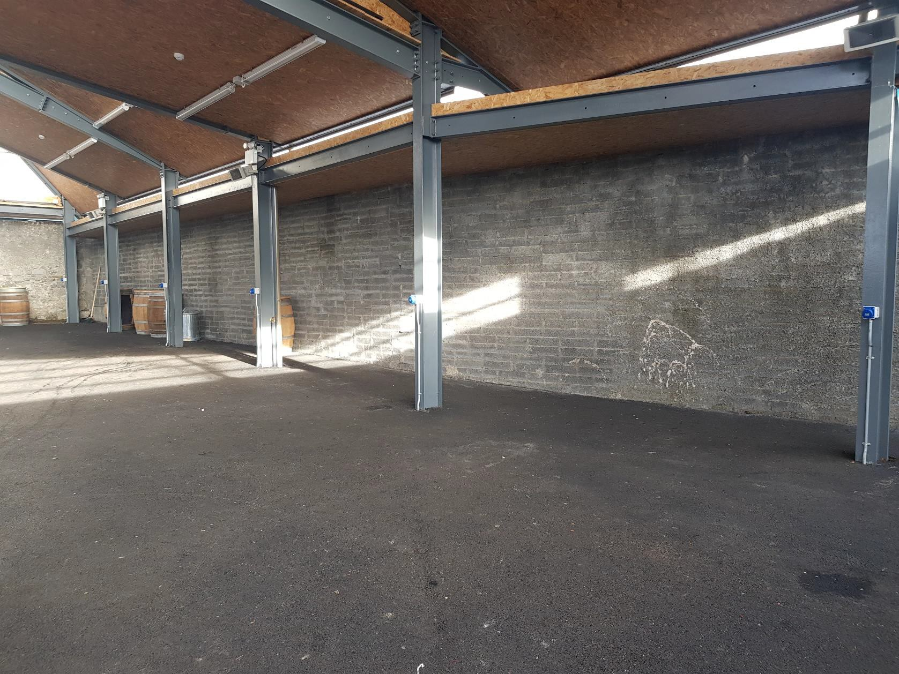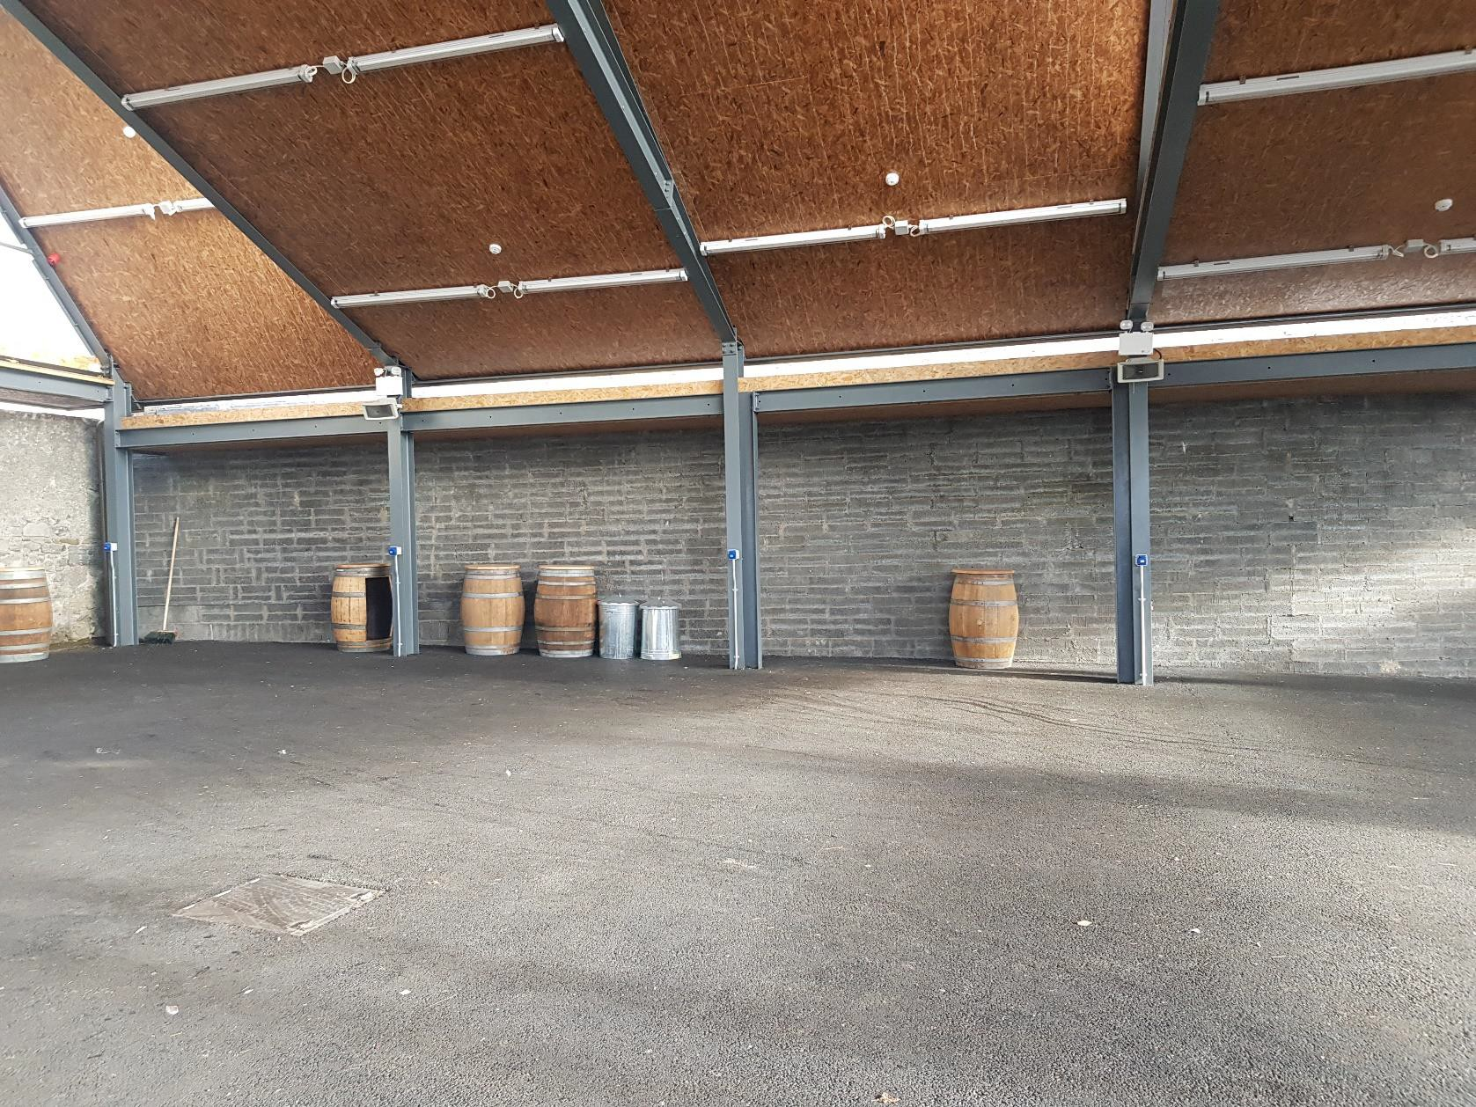
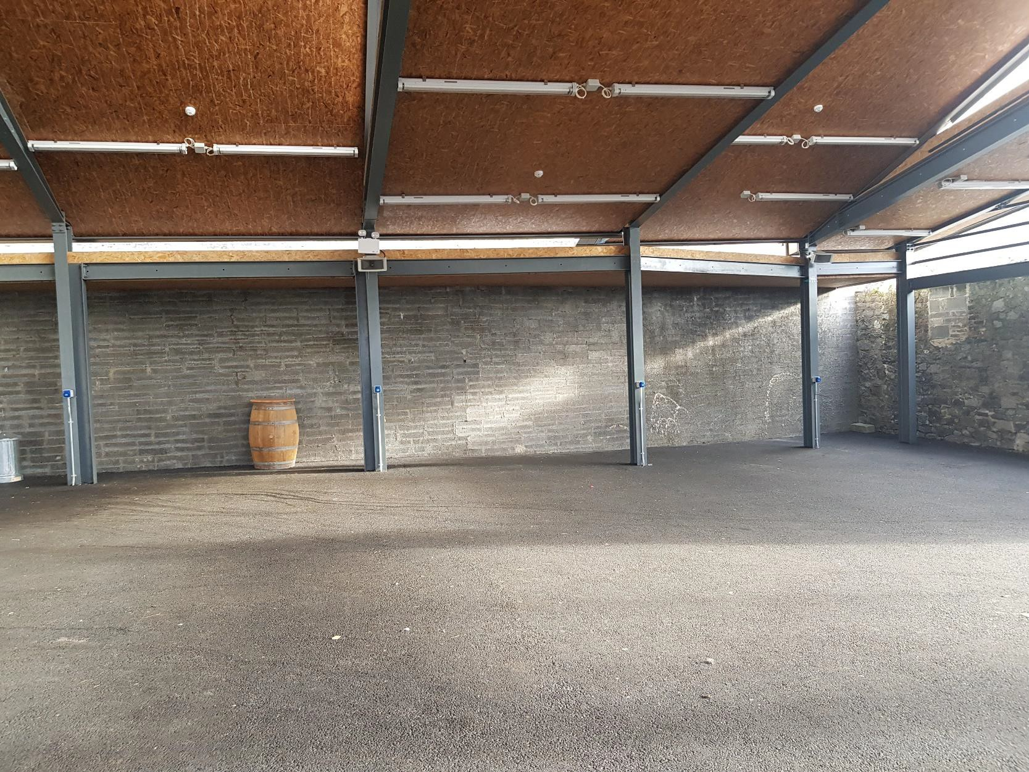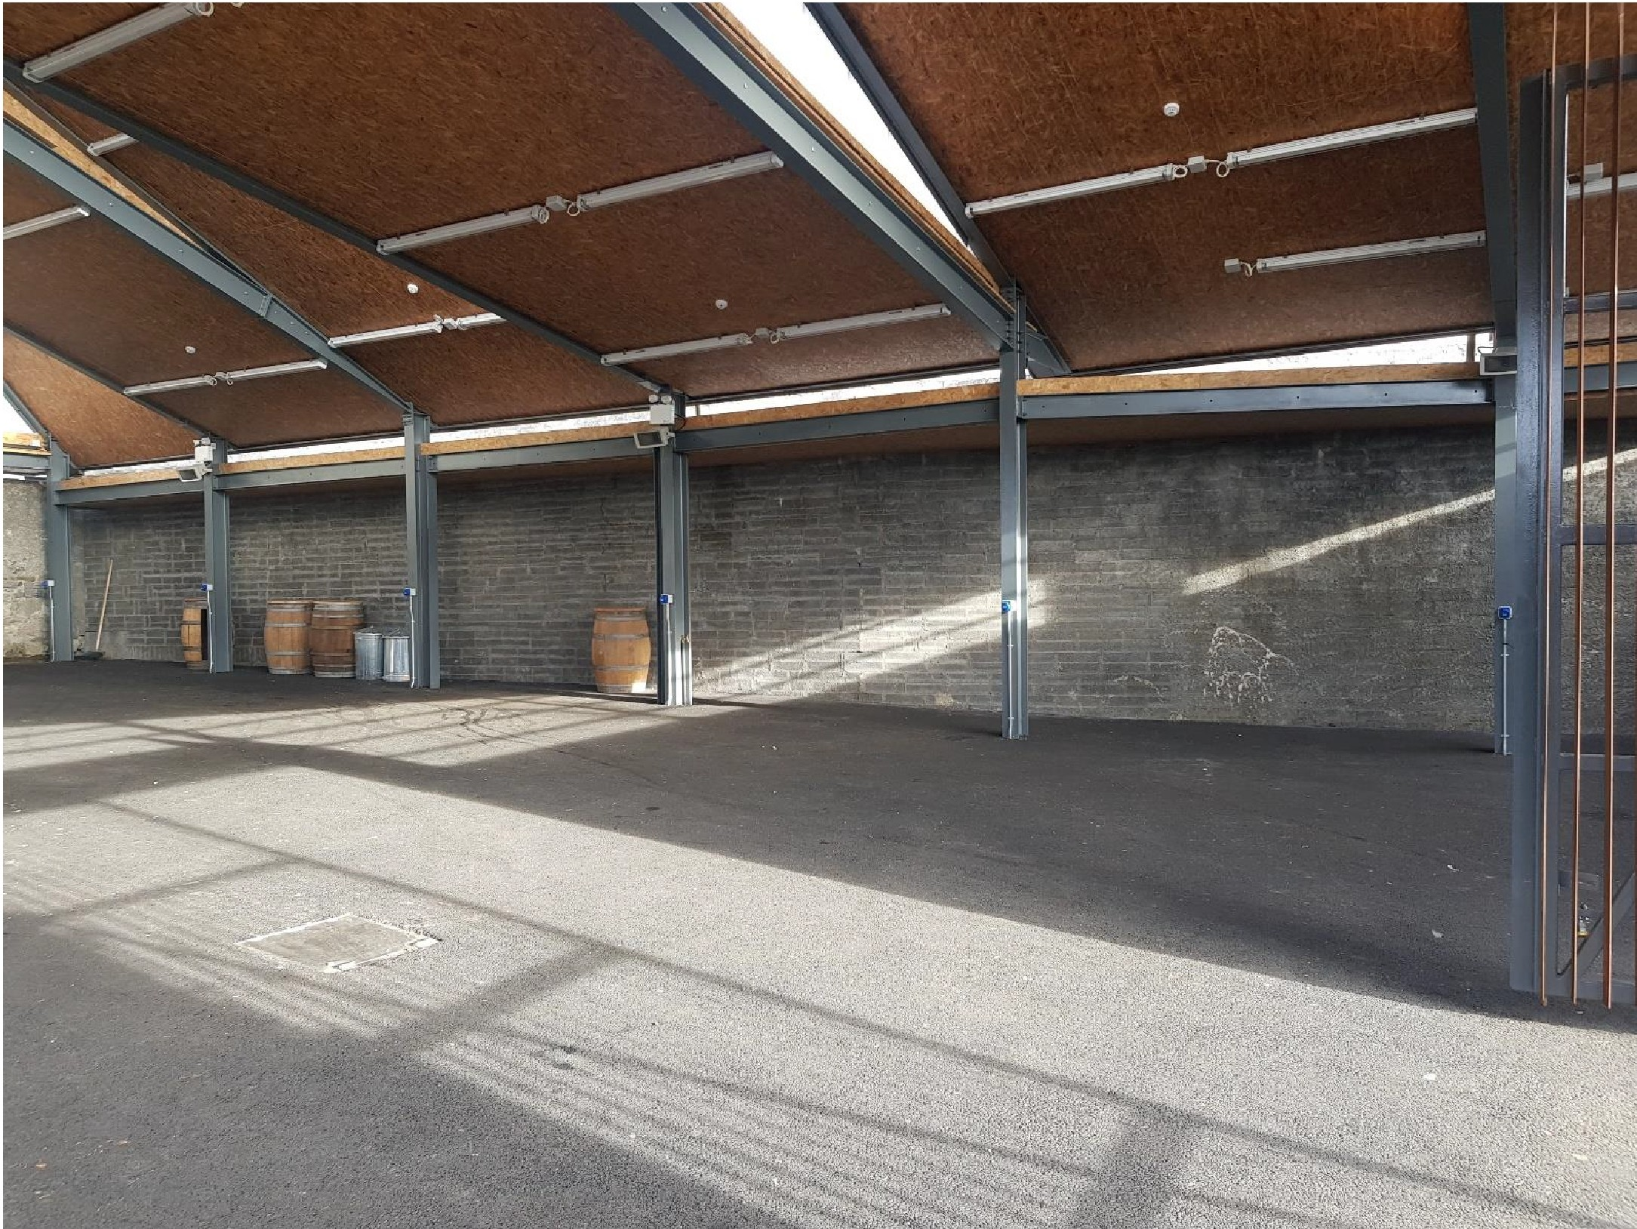

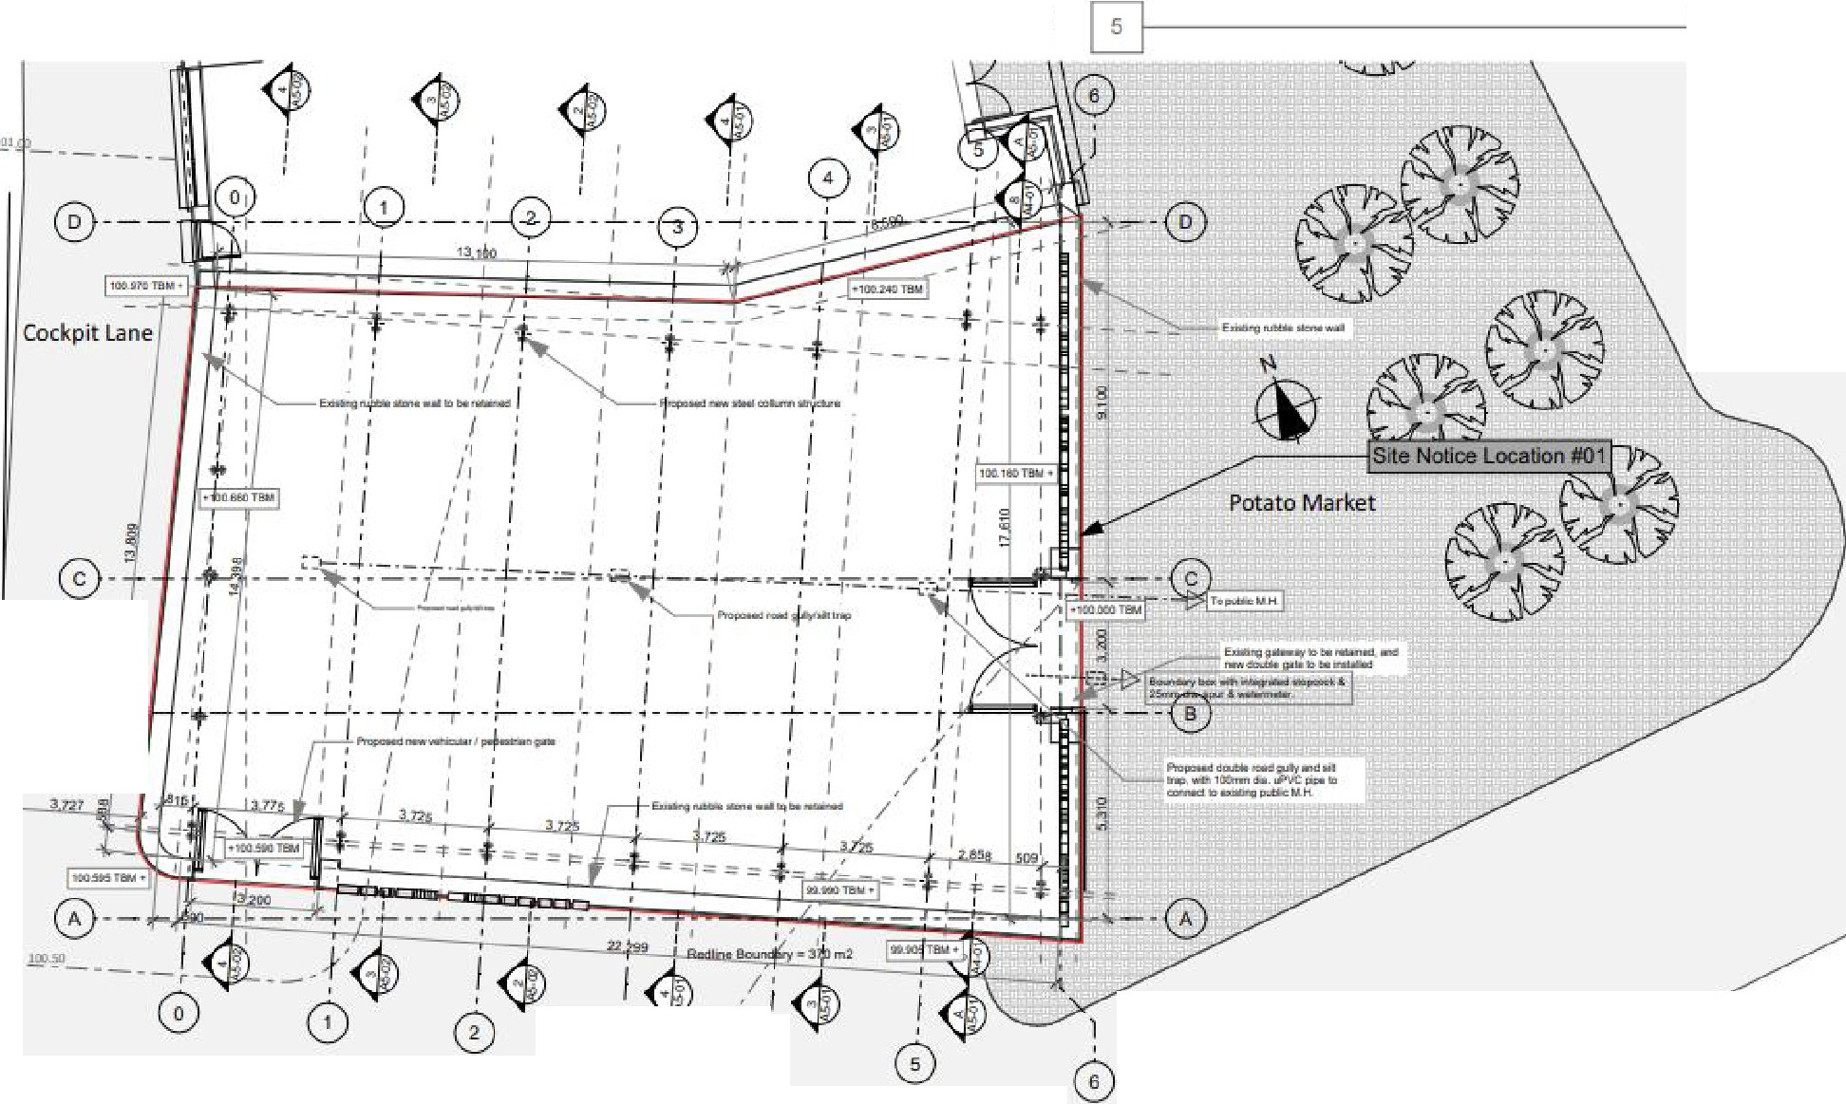

Appendix 1 – Sample Artist Contract

Mural – The Exchange Carlow Town.
AGREEMENT between Carlow County Council and (INSERT NAME) (hereinafter called ‘the Artist’).
1. Carlow County Council and the Artist have agreed that the Artist will make, provide, and install a Mural (hereinafter called ‘the Work’) in The Exchange Carlow Town in accordance with the terms and conditions hereinafter set out.
2. The value of the commission is (INSERT AMOUNT) (€ INSERT AMOUNT) ex VAT at 13.5%. This amount is fully inclusive of artists fees, materials, fabrication, foundations, installation costs, civil works, engineering design, health and safety requirements, labour, insurance and landscaping. Payment to the artist will be subject to Relevant Contracts Tax and Reverse Charge VAT rules in accordance with Revenue requirements. Payment will be made to the artist on foot of a valid invoice excluding VAT and marked “VAT accounted for by principal contractor”.
3. The Artist agrees to abide by the plans and photographs submitted for selection and subject thereto the Artist nonetheless reserves the right to make any aesthetic alterations which he considers necessary for the improvement of the piece. The Artist will consult with Carlow County Council regarding any such alterations.
4. The commission will be paid in (INSERT NUMBER) instalments as outlined below and prior to commencing work the Artist must produce proof of Tax Compliance in the Republic of Ireland and proof of appointment of a project supervisor for the design process (PSDP)
a) € (INSERT AMOUNT) (Ex VAT) to be paid in (INSERT MONTH) 2023 on commencement (when contract is signed, and all insurance documentation, Tax Clearance and PSDP appointment is in place)
b) € (INSERT AMOUNT) (Ex VAT) to be paid in (INSERT MONTH) 2023 (conditional on Carlow County Council being satisfied with the Work)
5. The artist agrees to complete the work by end September 2023 at the latest date.
6. The Artist will liaise directly with Carlow County Council with regard to the installation of the commissioned work at the agreed site and will agree a schedule for preparation and siting of the artwork with Carlow County Council.
a) The artist will appoint in writing, before design work starts, a competent and adequately resourced project supervisor for the design process (PSDP), (to be agreed in advance with Carlow County Council)
b) The artist will appoint in writing, before construction work starts, a competent and adequately resourced project supervisor for the construction process (PSCS), (to be agreed in advance with Carlow County Council)
c) The artist will submit and agree a method statement before construction work starts as to how each aspect of the commission will be delivered and installed, (to be agreed in advance with Carlow County Council)
d) The artist agrees to retain the expertise required for all matters relating to Health and Safety / Construction and Sub-Contracts. The artist will provide Health and Safety Statement associated with all works carried out.
e) The artist will adhere to all Public Health Guidelines.
f) The artist agrees to adequately secure the site against trespass and the fencing then maintained for the duration of the works. Arrangements to be put in place for 24/7 call out in the event of vandalism etc.
g) During installation the artist will ensure minimum impact on The Carlow Exchange area and then reinstatement of the area on completion.
7. The Artist hereby takes the responsibility for sound material and good craftsmanship and that any defects or weakness which appear within the Work within twelve months of the date of its handing over to Carlow County Council and which can be attributed to his negligence shall be repaired by him at his own expense. In the event that any damage occurs to the work during the installation due to natural disasters such as flooding or storm damage, the Artist shall undertake to co-operate in a consultative and supervisory capacity but without charge to Carlow County Council to enable such damage to the Work to be remedied.
8. The Artist agrees to provide insurance cover for himself and the work during the period of construction and siting, and for any other person(s) whether an employee or not an employee assisting the artist with the installation and siting of the work. Prior to commencing work at the site, the artist shall submit a copy of his Public Liability Insurance (minimum of €6.4m for any one claim) valid in the Republic of Ireland with an indemnity to Carlow County Council.
9. The Artist, where not carrying out all aspects of the works himself but having aspects of the construction and erection of the Work carried out on his behalf, shall provide such evidence as the Council may reasonably require that the person carrying out the work on behalf of the Artist has Public Liability of €6.4m and Employer’s Liability cover of €13m in respect of any one claim.
10. The Artist understands that while working on the site the normal hours of work, 8.00 am to 16.30 pm Monday to Friday, will pertain. Work outside these hours, if necessary, will be by special arrangement.
11. The Artist hereby covenants not to reproduce the Work in the future at any other location for any other employer.
12. The Artist agrees that as part of his obligation to Carlow County Council, he shall supply such information (without payment) as it may reasonably require so as to maintain the work in good order and condition.
13. If the Artist defaults in carrying out his obligations under this agreement, then Carlow County Council may, on giving not less than fourteen days’ notice to the Artist, terminate this agreement and no further sums shall be payable to the Artist. Carlow County Council reserves the right to recover any suns paid to the Artist in the event of the agreement being terminated.
14. The Artist agrees that on completion and erection the Work will be the property of Carlow County Council.
15. Carlow County Council shall be entitled without payment to the Artist to make (or authorise others to make) any photographic reproductions, film, video, or other multimedia reproductions of the Work and to include this in any social media, advertising, brochures or other publicity materials or broadcasts provided that such reproduction is intended to promote or record the Work and is used for non-commercial purposes.
16. Carlow County Council hereby agrees to identify the Artist as the creator of the Work on all occasions when the Work or other permitted reproduction is exhibited, published, or issued to the public.

SIGNED:

