National Enterprise Awards Limerick 2017
Application Form
(Strictly Confidential)
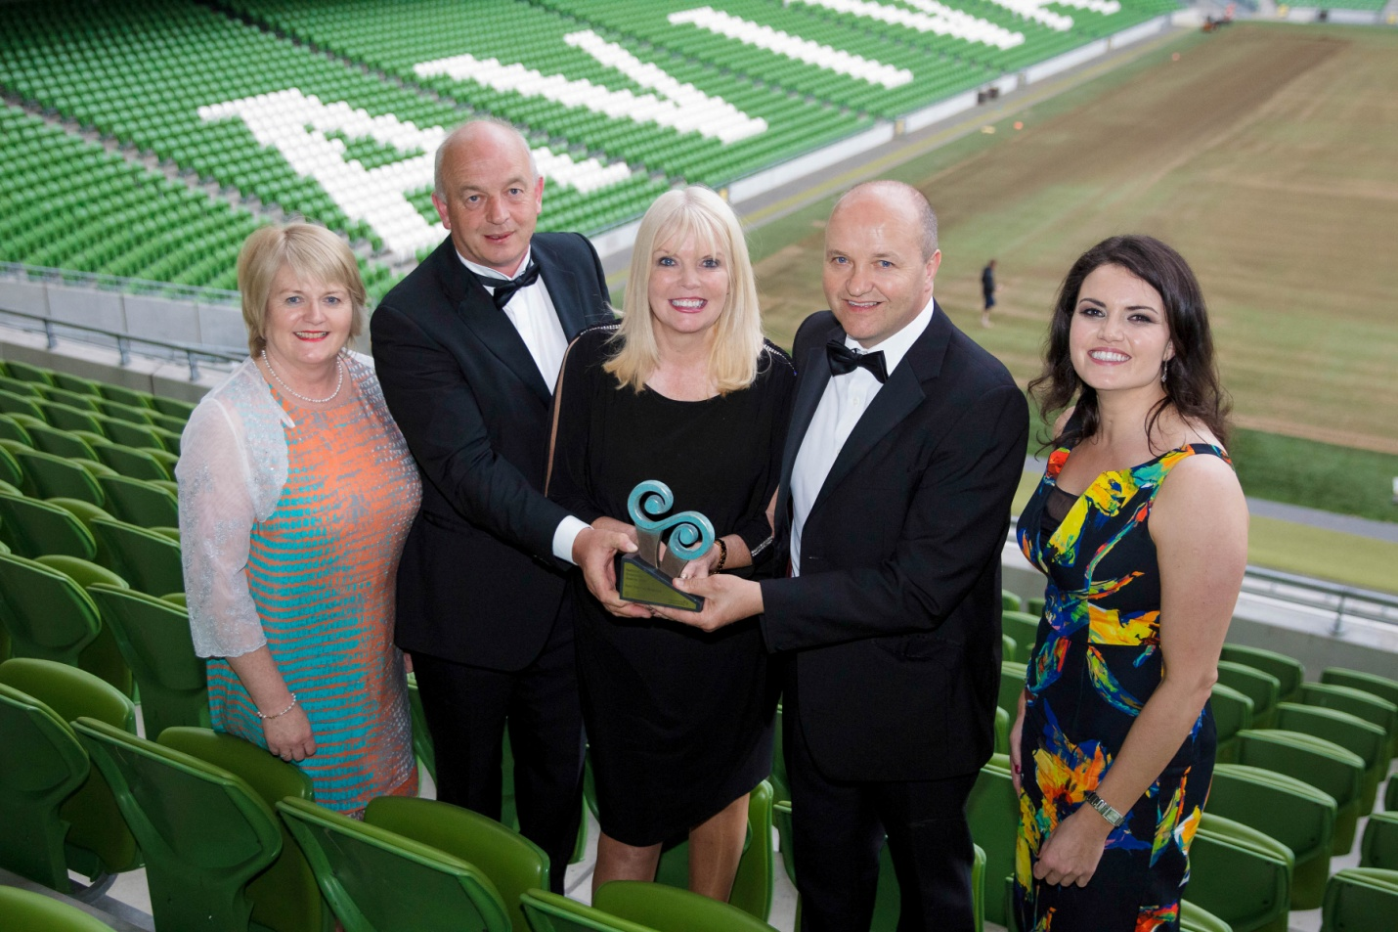

Limerick Winners and National Category Winners 2016 – Bespoke Sauce Company Ltd., Raheen

Sponsored
By

GENERAL INFORMATION
Name of Applicant: __________________________________________
Address: __________________________________________
__________________________________________
Region: __________________________________________
Legal Status: (Tick one) Sole Trader Partnership Limited Company
Date of Commencement of Business: _________________________ ______
Phone. : _______________________ Business ______________________ (Mob)
Website : _____________________ e- mail:____________________________

Business Information
What product or service do you supply?

Describe your own background and why you set up in business?

What do you see as the key strengths of your business?

In what way and when, did your Local Enterprise Office help you (formerly CEB)? (Please include the year, type and level of support i.e. Grant aid and /or Training Supports)

Has this business been grant aided by any other government agency such as Enterprise Ireland, An Bord Bia, Leader Partnership, Inter Trade etc . (If so give details i.e. Agency, Year, Grant Amount, Type etc)

Marketing Your Business
Describe what is different or innovative about your product or service?

Is your customer base local, regional, national, international? Please give details.

How do you market your business?

Are there potential new markets for your business and how do you plan to take advantage of these opportunities?

Social Media
What forms of social media do you use to promote your business and describe any campaigns you have undertaken?

Technology
How do you use technology in your business?

The Future of your Business
What long-term plans do you have for your business and how do you see it growing and developing over the next 3 years?

What do you see as the key threats/weaknesses to your business? How do you propose to address them?

Employment Details
 | 31/12/2014 | 31/12/2015 | 31/12/2016 | Projected 2017
Full Time
Part Time

Financial Details
Business Growth | 2014 | 2015 | 2016
Annual Sales
Net Profit

Investment | 2014 | 2015 | 2016
Own Funds
Loans
Grants
TOTAL

(Please return your completed application form, together with a current Business Plan and financial statements to your Local Enterprise Office by the indicated deadline.
______________________

Signed: _________________________________

Date: ____________________________________

