RS 8.4 (c) Rev 03
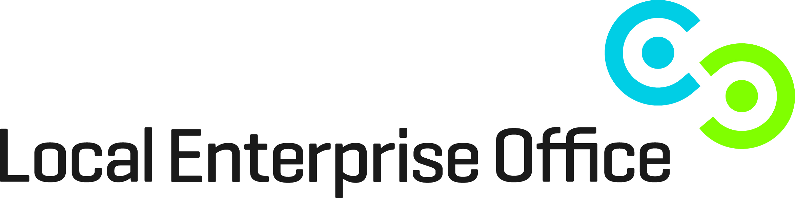 CUSTOMER DEVELOPMENT SUPPORTS EVALUATION FORM

One to One Programmes
Westmeath Local Enterprise Office continuously evaluates its range of Project and Enterprise Support Programmes for small business .We would be grateful if you would complete this evaluation form.

Section A

Participant Name: ___________________________________________________________

Business Name: _________________________________________________________

Address: __________________________________________________________________

Telephone No: _______________________________________________

E-Mail: _______________________________________________

Section B

Programme Delivery

Training/Mentoring Name: ___________________________________ Date __________________________

- How effective do you feel this clinic/one to one was to your business?

- Please rate on a scale of 1 to 10

The Trainer 1 2 3 4 5 6 7 8 9 10

- Was your objective achieved with the Trainer? □Yes □No

- Do you wish to make any additional comment?

Signed: ____________________________________ Date: _________________

The Local Enterprise Office is committed to its transparency obligations under the General Data Protection Regulation (GDPR). Our data protection notice for personal data that is supplied to us by our clients is available at www.localenterprise.ie/legal This notice tells you about your privacy rights and sets out how we, as a Controller, collect, use, process and disclose your personal data relating to your interactions with us. We request that you read the notice carefully and that you ensure that it is made available to any data subjects (e.g. your employees) whose personal data you provide to us.

Office Use Only: Overall Assessment of Trainer:
□ Excellent □ Very Good □ Good □ Satisfactory □ Unsatisfactory
Comments:

Signed: ________________________________ Date: ________________________

Westmeath Local Enterprise Office, County Buildings, Mullingar
Tel. (044) 9338945 / E-Mail: info@leo.westmeathcoco.ie

