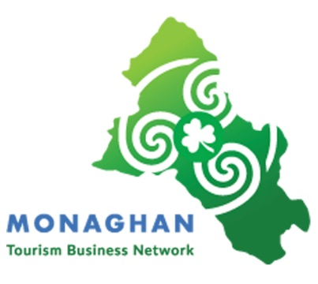

Monaghan Tourism Business Network Application Form

Please fill in as much information as possible. Additional information to support your application can be added to end of form as indicated.

SECTION A: Applicant Details

Applicant’s Name:
Address (Line 1):
Address (Line 2):
Address (County):
E-mail Address:
Telephone Number:
Company Trading Name
Web Address (or network sites, e.g. LinkedIn, Facebook, etc.) (if any):
How did you learn of this Programme?
List any past participation in business development programmes (State and/or private sector):
Sector: Tourism Hospitality
Tourism Activity
Tourism Craft

Demonstrate your business relevance to the Network

SECTION B: Demonstrate your business relevance to the Network

1. Give brief details of your tourism business
Type here....(Max 250 characters)

2. Have you taken any steps yet to deal with the impact of Covid -19?
Type here…. (Max 250 characters)

3. What is your product/service
Type here....(Max 250 characters)

4. How will participating in this Network benefit your business?
Type here....(Max 250 characters)

5. What supports provided by this Network is most relevant to your business and why?
Type here....(Max 250 characters)

6. How will participating on this Network benefit your future business?
Type here....(Max 250 characters)

7 What innovation would you like to implement as a result of participating in this Network?
Type here....(Max 250 characters)

Additional Information to support your application:

Local Enterprise office Monaghan - GDPR Consent Statement
Local Enterprise Office Monaghan is committed to its transparency obligations under the General Data Protection Regulation (GDPR). Our data protection notice for personal data that is supplied to us by our clients is available at www.localenterprise.ie/Monaghan/Legal/GDPR

Signature: | Date

Closing date for Applications: 17/4/20

Please return form
By email to: eilin.connolly@leo.monaghancoco.ie

